Name: Mariel Joy A. Casicas Date: 04-06-2026
Yr & Sec: BSIT 3 – B

Activity 2: UML Diagram Design Project

“Youth Ministry Activity Tracker System”

- Brief System Description.

The Youth Ministry Activity Tracker System is designed to help youth leaders to manage and organize church activities efficiently. This system allows youth leaders to create, view, update, and delete youth ministry activities such as events, gatherings, and outreach programs and it also enable members to view the activity information. It provides a centralized platform where all activity information like name, date, location, and description can be stored and accessed easily.
Through this system, youth leaders can easily monitor any upcoming activities and ensure proper coordination within the ministry. It also helps improve organization, communication, and record-keeping, making it easier to manage multiple events and keep track of important details.

- Actors/Users
Admin (Youth Leader)
Member (Viewer only)

- Main System Functions
- Add Activity
- View Activities
- View Activity Details
- Edit Activity
- Delete Activity
- View Featured Activity

- UML Diagram “USE Case Diagram”
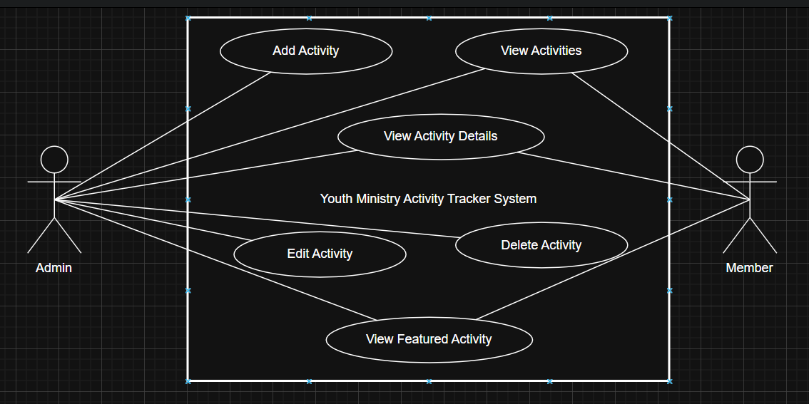

Short Explanation:
The Use Case Diagram provided illustrates how the Admin interacts with the Youth Ministry Activity Tracker System. The Admin is responsible for managing all activities, including adding, viewing, updating, and deleting records, and the member is able to view it’s activities, details, and features. Each function represents a specific task that helps organize youth ministry events efficiently. The system ensures that all activity information is accessible and manageable in one platform. This improves coordination and overall productivity within the ministry.

